**Object Oriented Programming**

**Cheat Sheet**

**Class and Object :**

**Java Class:**

A class in Java is a set of objects which shares common characteristics/ behavior and common properties/ attributes. It is a user-defined blueprint or prototype from which objects are created. For example, Student is a class while a particular student named Ravi is an object.

**Properties of Java Classes:**

1. Class is not a real-world entity. It is just a template or blueprint or prototype from which objects are created.
2. Class does not occupy memory.
3. Class is a group of variables of different data types and a group of methods.
4. A Class in Java can contain:
   * Data member
   * Method
   * Constructor
   * Nested Class
   * Interface

**Java Objects**

An object in Java is a basic unit of Object-Oriented Programming and represents real-life entities. Objects are the instances of a class that are created to use the attributes and methods of a class. A typical Java program creates many objects, which as you know, interact by invoking methods. An object consists of :

* State: It is represented by attributes of an object. It also reflects the properties of an object.
* Behavior: It is represented by the methods of an object. It also reflects the response of an object with other objects.
* Identity: It gives a unique name to an object and enables one object to interact with other objects.

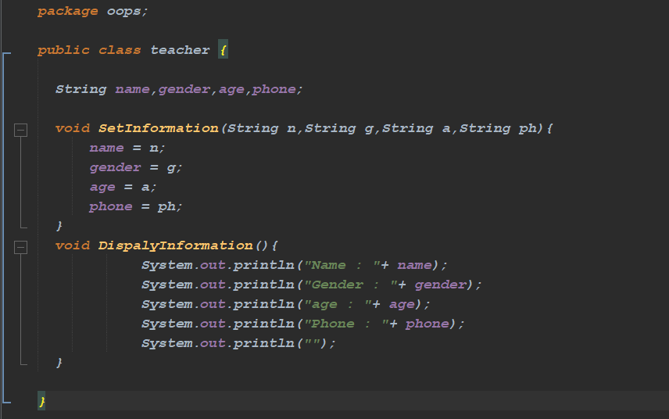**Create Class:**

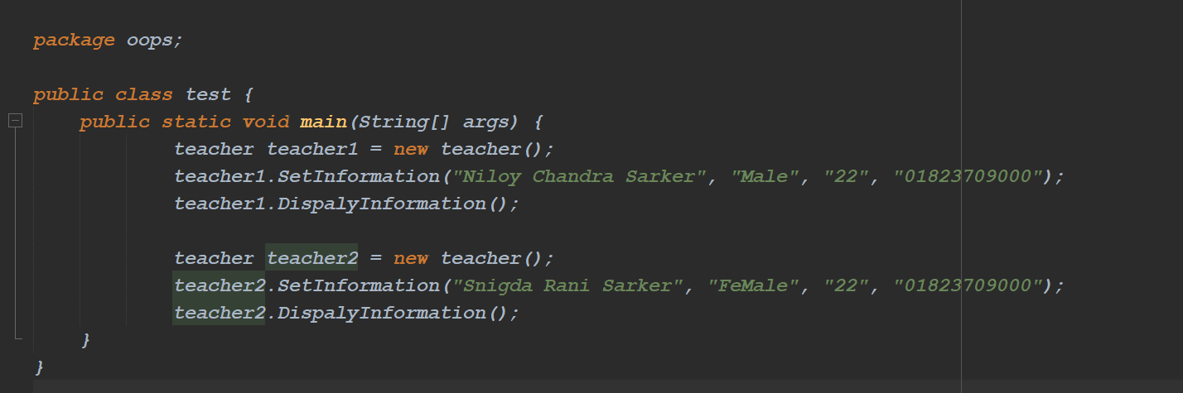**Create object and all method**

**Constructor**

* Constructor is a special type of metehod that is used to initialize the object .
* Properties of constructor.
* Constructor is the same name as that of the class it belongs.
* It has no return type not even void.
* It is called automatically.
* Default constructor(No Perameter) Peramiterized constructor.

